**TUGAS PRAKTEK ALGORITMA PEMROGRAMAN**

**(CONTOH)**



Faathir Akbar Nugroho

4522210033

A

Pseudocode (Contoh 1)

ALGORITMA

KAMUS/DEKLARASI VARIABEL

Faathir, Akbar[Faathir], Nugroho, i : int

ALGORITMA/DESKRIPSI

Faathir = 3

Akbar[Faathir] = {22,7,1966}

for (i = 0; i < Faathir; i++)

Nugroho = Nugroho+Akbar[i]

Endfor

Print(Nugroho)

Algoritma/Bahasa alami (Contoh 1)

1. Faathir = 3

2. i = 0

3. Akbar[Faathir] = {22,7,1966}

4. Selama (i<Faathir ) kerjakan baris 5 s.d. 7

5. Menghitung Nugroho 🡨 Nugroho + Akbar[i]

6. Mencetak isi/variabel Nugroho

7. i++

8. Selesai

Program (Contoh 1)

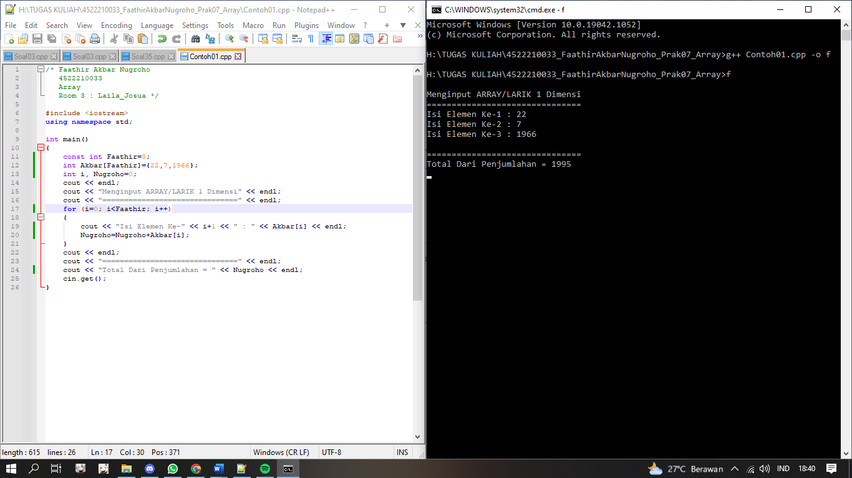

Algoritma/Bahasa alami (Soal 1)

1. Const Akbar = 7

2. Faathir = 0

3. Selama (Faathir < Akbar) kerjakan baris 4 s.d 6, kalau tidak kerjakan baris 7

4. Mencetak isi/variabel (Faathir + 1)

5. Menginput isi/variabel Nugroho[1]

6. Faathir++

7. Selama (Faathir < Akbar) kerjakan baris baris 8 s.d 10, kalau tidak kerjakan baris 11

8. Mencetak isi/variabel (Faathir + 1)

9. Mencetak isi/variabel Nugroho[Faathir]

10. Faathir++

11. Selesai

Program (Soal 1)

